**Bootstrap continuation**

**Lab report #05**



Fall 2023

CSE-423L Web Engineering

Submitted by: **Ashfaq Ahmad**

Registration No: **19PWCSE1795**

Class Section: **B**

“On my honor, as student of University of Engineering and Technology, I have neither given nor received unauthorized assistance on this academic work.”

Student Signature: ______________

Submitted to:

**Eng. Usman Malik**

**May** 27, 2023

**Department of Computer Systems Engineering**

**University of Engineering and Technology, Peshawar**

**Task 01:**

Carousel

**Bootstrap Code:**

<!doctype html>

<html lang="en">

  <head>

    <meta charset="utf-8">

    <meta name="viewport" content="width=device-width, initial-scale=1">

    <title>Bootstrap demo</title>

    <link href="https://cdn.jsdelivr.net/npm/bootstrap@5.3.0-alpha3/dist/css/bootstrap.min.css" rel="stylesheet" integrity="sha384-KK94CHFLLe+nY2dmCWGMq91rCGa5gtU4mk92HdvYe+M/SXH301p5ILy+dN9+nJOZ" crossorigin="anonymous">

    <style>

        .carousel{

            height: 50vh;

            width: 50vw;

            position: absolute;

            border: 3px solid red;

            top: 100px;

            left: 20vw;

        }

        img{

            height: 49.20vh;

        }

    </style>

  </head>

  <body>

    <div id="carouselExampleCaptions" class="carousel slide">

        <div class="carousel-indicators">

          <button type="button" data-bs-target="#carouselExampleCaptions" data-bs-slide-to="0" class="active" aria-current="true" aria-label="Slide 1"></button>

          <button type="button" data-bs-target="#carouselExampleCaptions" data-bs-slide-to="1" aria-label="Slide 2"></button>

          <button type="button" data-bs-target="#carouselExampleCaptions" data-bs-slide-to="2" aria-label="Slide 3"></button>

        </div>

        <div class="carousel-inner">

          <div class="carousel-item active">

            <img src="https://jssors8.azureedge.net/demos/image-slider/img/px-bloom-blossom-flora-65219-image.jpg" class="d-block " alt="...">

            <div class="carousel-caption d-none d-md-block">

              <h5>Slide One</h5>

              <p>Some representative placeholder content for the first slide.</p>

            </div>

          </div>

          <div class="carousel-item">

            <img src="https://jssors8.azureedge.net/demos/image-slider/img/faded-monaco-scenery-evening-dark-picjumbo-com-image.jpg" class="d-block ">

            <div class="carousel-caption d-none d-md-block">

              <h5>Slide Two</h5>

              <p>Some representative placeholder content for the second slide.</p>

            </div>

          </div>

          <div class="carousel-item">

            <img src="https://jssors8.azureedge.net/demos/image-slider/img/px-action-athlete-athletes-848618-image.jpg" class="d-block ">

            <div class="carousel-caption d-none d-md-block">

              <h5>Slide Three</h5>

              <p>Some representative placeholder content for the third slide.</p>

            </div>

          </div>

        </div>

        <button class="carousel-control-prev" type="button" data-bs-target="#carouselExampleCaptions" data-bs-slide="prev">

          <span class="carousel-control-prev-icon" aria-hidden="true"></span>

          <span class="visually-hidden">Previous</span>

        </button>

        <button class="carousel-control-next" type="button" data-bs-target="#carouselExampleCaptions" data-bs-slide="next">

          <span class="carousel-control-next-icon" aria-hidden="true"></span>

          <span class="visually-hidden">Next</span>

        </button>

      </div>

    <script src="https://cdn.jsdelivr.net/npm/bootstrap@5.3.0-alpha3/dist/js/bootstrap.bundle.min.js" integrity="sha384-ENjdO4Dr2bkBIFxQpeoTz1HIcje39Wm4jDKdf19U8gI4ddQ3GYNS7NTKfAdVQSZe" crossorigin="anonymous"></script>

  </body>

</html>

**Result:**

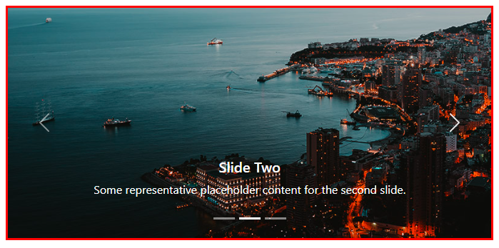

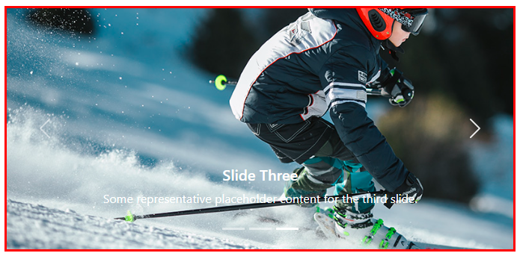

**Task 02:**

Collapse

**Bootstrap Code:**

<!doctype html>

<html lang="en">

<head>

    <!-- Required meta tags -->

    <meta charset="utf-8">

    <meta name="viewport" content="width=device-width, initial-scale=1, shrink-to-fit=no">

    <!-- Bootstrap CSS -->

    <link rel="stylesheet" href="https://cdn.jsdelivr.net/npm/bootstrap@4.6.2/dist/css/bootstrap.min.css"

        integrity="sha384-xOolHFLEh07PJGoPkLv1IbcEPTNtaed2xpHsD9ESMhqIYd0nLMwNLD69Npy4HI+N" crossorigin="anonymous">

    <title>Hello, world!</title>

    <style>

        .layout{

            margin: 50px;

            width: 70vw;

        }

    </style>

</head>

<body>

<div class="layout">

    <p>

        <button class="btn btn-primary" type="button" data-toggle="collapse" data-target="#collapseExample"

            aria-expanded="false" aria-controls="collapseExample">

            Read More

        </button>

    </p>

    <div class="collapse" id="collapseExample">

        <div class="card card-body">

            Some placeholder content for the collapse component. This panel is hidden by default but revealed when the

            user activates the relevant trigger.

        </div>

    </div>

    <br>

    <br>

    <div class="accordion" id="accordionExample">

        <div class="card">

            <div class="card-header" id="headingOne">

                <h2 class="mb-0">

                    <button class="btn btn-link btn-block text-left" type="button" data-toggle="collapse"

                        data-target="#collapseOne" aria-expanded="true" aria-controls="collapseOne">

                        Collapse One

                    </button>

                </h2>

            </div>

            <div id="collapseOne" class="collapse show" aria-labelledby="headingOne" data-parent="#accordionExample">

                <div class="card-body">

                    Some placeholder content for the first accordion panel. This panel is shown by default, thanks to

                    the <code>.show</code> class.

                </div>

            </div>

        </div>

        <div class="card">

            <div class="card-header" id="headingTwo">

                <h2 class="mb-0">

                    <button class="btn btn-link btn-block text-left collapsed" type="button" data-toggle="collapse"

                        data-target="#collapseTwo" aria-expanded="false" aria-controls="collapseTwo">

                        Collapse Two

                    </button>

                </h2>

            </div>

            <div id="collapseTwo" class="collapse" aria-labelledby="headingTwo" data-parent="#accordionExample">

                <div class="card-body">

                    Some placeholder content for the second accordion panel. This panel is hidden by default.

                </div>

            </div>

        </div>

        <div class="card">

            <div class="card-header" id="headingThree">

                <h2 class="mb-0">

                    <button class="btn btn-link btn-block text-left collapsed" type="button" data-toggle="collapse"

                        data-target="#collapseThree" aria-expanded="false" aria-controls="collapseThree">

                        Collapse Three

                    </button>

                </h2>

            </div>

            <div id="collapseThree" class="collapse" aria-labelledby="headingThree" data-parent="#accordionExample">

                <div class="card-body">

                    And lastly, the placeholder content for the third and final accordion panel. This panel is hidden by

                    default.

                </div>

            </div>

        </div>

    </div>

</div>

    <script src="https://cdn.jsdelivr.net/npm/jquery@3.5.1/dist/jquery.slim.min.js"

        integrity="sha384-DfXdz2htPH0lsSSs5nCTpuj/zy4C+OGpamoFVy38MVBnE+IbbVYUew+OrCXaRkfj"

        crossorigin="anonymous"></script>

    <script src="https://cdn.jsdelivr.net/npm/bootstrap@4.6.2/dist/js/bootstrap.bundle.min.js"

        integrity="sha384-Fy6S3B9q64WdZWQUiU+q4/2Lc9npb8tCaSX9FK7E8HnRr0Jz8D6OP9dO5Vg3Q9ct"

        crossorigin="anonymous"></script>

</body>

</html>

**Result:**

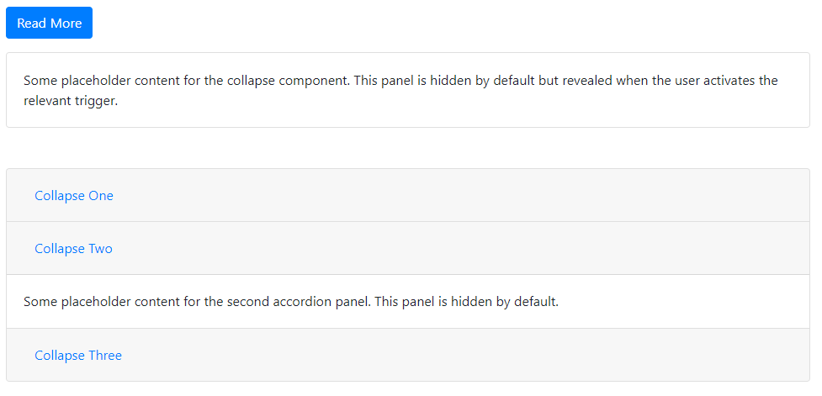

**Task 03:**

Tooltips

**Bootstrap Code:**

<!doctype html>

<html lang="en">

<head>

    <!-- Bootstrap CSS -->

    <link rel="stylesheet" href="https://cdn.jsdelivr.net/npm/bootstrap@4.6.2/dist/css/bootstrap.min.css"

        integrity="sha384-xOolHFLEh07PJGoPkLv1IbcEPTNtaed2xpHsD9ESMhqIYd0nLMwNLD69Npy4HI+N" crossorigin="anonymous">

    <script src="https://ajax.googleapis.com/ajax/libs/jquery/3.6.4/jquery.min.js"></script>

    <title>Hello, world!</title>

    <style>

        .layout {

            margin: 20px;

        }

    </style>

</head>

<body>

    <div class="layout border-top border-bottom p-3">

        <br><br>

        <button type="button" class="btn btn-primary" data-toggle="tooltip" data-placement="top" title="Tooltip on top">

            Tooltip on top

        </button>

        <button type="button" class="btn btn-success" data-toggle="tooltip" data-placement="left"

            title="Tooltip on left">

            Tooltip on left

        </button>

        <button type="button" class="btn btn-warning" data-toggle="tooltip" data-placement="bottom"

            title="Tooltip on bottom">

            Tooltip on bottom

        </button>

        <button type="button" class="btn btn-danger" data-toggle="tooltip" data-placement="right"

            title="Tooltip on right">

            Tooltip on right

        </button>

        <br><br>

        <button type="button" class="btn btn-primary" data-toggle="tooltip" data-html="true" title="<em>Tooltip</em> <u>with</u> <b>HTML</b>">

            Tooltip with HTML

        </button>

    </div>

    <div class="layout">

        <button id="btn1" type="button" class="btn btn-secondary" data-toggle="tooltip" data-placement="bottom"

        title="Show Tooltip">

            Show Tooltip

        </button>

        <button id="btn2" type="button" class="btn btn-secondary" data-toggle="tooltip" data-placement="bottom"

        title="Hide tooltip">

            Hide Tooltip

        </button>

        <button id="btn3" type="button" class="btn btn-secondary" data-toggle="tooltip" data-placement="bottom"

        title="Toggle Tooltip">

            Toggle Tooltip

        </button>

    </div>

    <script>

        $(function () {

        $('[data-toggle="tooltip"]').tooltip()

         })

        $(document).ready(function () {

            $('#btn1').click(function () {$('#btn1').tooltip('show')})

            $('#btn2').click(function () {$('#btn2').tooltip('hide')})

            $('#btn3').click(function () {$('#btn3').tooltip('toggle')})

        })

    </script>

    <script src="https://cdn.jsdelivr.net/npm/jquery@3.5.1/dist/jquery.slim.min.js" integrity="sha384-DfXdz2htPH0lsSSs5nCTpuj/zy4C+OGpamoFVy38MVBnE+IbbVYUew+OrCXaRkfj" crossorigin="anonymous"></script>

    <script src="https://cdn.jsdelivr.net/npm/bootstrap@4.6.2/dist/js/bootstrap.bundle.min.js" integrity="sha384-Fy6S3B9q64WdZWQUiU+q4/2Lc9npb8tCaSX9FK7E8HnRr0Jz8D6OP9dO5Vg3Q9ct" crossorigin="anonymous"></script>

</body>

</html>

**Result:**

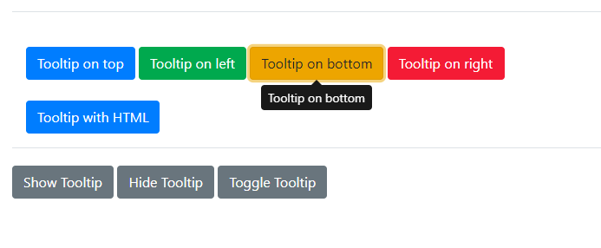

**Task 04:**

Popover

**Bootstrap Code:**

<!doctype html>

<html lang="en">

<head>

    <!-- Required meta tags -->

    <meta charset="utf-8">

    <meta name="viewport" content="width=device-width, initial-scale=1, shrink-to-fit=no">

    <!-- Bootstrap CSS -->

    <link rel="stylesheet" href="https://cdn.jsdelivr.net/npm/bootstrap@4.6.2/dist/css/bootstrap.min.css"

        integrity="sha384-xOolHFLEh07PJGoPkLv1IbcEPTNtaed2xpHsD9ESMhqIYd0nLMwNLD69Npy4HI+N" crossorigin="anonymous">

    <script src="https://ajax.googleapis.com/ajax/libs/jquery/3.6.4/jquery.min.js"></script>

    <title>Hello, world!</title>

    <style>

        .layout {

            margin: 30px;

        }

    </style>

</head>

<body>

    <div class="layout border-bottom border-top p-4">

        <button type="button" class="btn btn-danger" data-container="body" data-toggle="popover" data-placement="top"

            data-content="Top popover">

            Popover on Top

        </button>

        <button type="button" class="btn btn-primary" data-container="body" data-toggle="popover" data-placement="right"

            data-content="left popover">

            Popover on left

        </button>

        <button type="button" class="btn btn-warning" data-container="body" data-toggle="popover"

            data-placement="bottom" data-content="Lorem ipsum dolor sit, amet consectetur adipisicing elit.">

            Popover on bottom

        </button>

        <button type="button" class="btn btn-success" data-container="body" data-toggle="popover" data-placement="right"

            data-content="right popover">

            Popover on right

        </button>

    </div>

    <div class="layout">

        <button id="btn1" type="button" class="btn btn-secondary" data-container="body" data-toggle="popover"

            data-placement="bottom" data-content="Bottom popover">

            Show popover

        </button>

        <button id="btn2" type="button" class="btn btn-secondary" data-container="body" data-toggle="popover"

            data-placement="bottom" data-content="Bottom popover">

            Hide popover

        </button>

        <button id="btn3" type="button" class="btn btn-secondary" data-container="body" data-toggle="popover"

            data-placement="bottom" data-content="Bottom popover">

            Toggle popover

        </button>

    </div>

    <script>

        $(function () {

            $('[data-toggle="popover"]').popover()

            $('#btn1').popover('show');

            $('#btn2').popover('hide');

            $('#btn3').popover('toggle');

        })

    </script>

    <!-- Option 1: jQuery and Bootstrap Bundle (includes Popper) -->

    <script src="https://cdn.jsdelivr.net/npm/jquery@3.5.1/dist/jquery.slim.min.js"

        integrity="sha384-DfXdz2htPH0lsSSs5nCTpuj/zy4C+OGpamoFVy38MVBnE+IbbVYUew+OrCXaRkfj"

        crossorigin="anonymous"></script>

    <script src="https://cdn.jsdelivr.net/npm/bootstrap@4.6.2/dist/js/bootstrap.bundle.min.js"

        integrity="sha384-Fy6S3B9q64WdZWQUiU+q4/2Lc9npb8tCaSX9FK7E8HnRr0Jz8D6OP9dO5Vg3Q9ct"

        crossorigin="anonymous"></script>

</body>

</html>

**Result:**

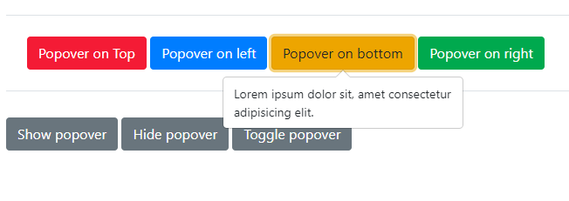

**Task05:**

Modals

Bootstrap Code:

<!doctype html>

<html lang="en">

<head>

    <!-- Required meta tags -->

    <meta charset="utf-8">

    <meta name="viewport" content="width=device-width, initial-scale=1, shrink-to-fit=no">

    <script src="https://ajax.googleapis.com/ajax/libs/jquery/3.6.4/jquery.min.js"></script>

    <!-- Bootstrap CSS -->

    <link rel="stylesheet" href="https://cdn.jsdelivr.net/npm/bootstrap@4.6.2/dist/css/bootstrap.min.css"

        integrity="sha384-xOolHFLEh07PJGoPkLv1IbcEPTNtaed2xpHsD9ESMhqIYd0nLMwNLD69Npy4HI+N" crossorigin="anonymous">

    <title>Hello, world!</title>

    <style>

        .layout {

            margin: 50px;

        }

    </style>

</head>

<body>

    <div class="layout">

        <!-- Button trigger modal -->

        <button type="button" class="btn btn-primary" data-toggle="modal" data-target="#exampleModal">

            Launch Modal

        </button>

        <!-- Modal -->

        <div class="modal fade" id="exampleModal" tabindex="-1" aria-labelledby="exampleModalLabel" aria-hidden="true">

            <div class="modal-dialog">

                <div class="modal-content">

                    <div class="modal-header">

                        <h5 class="modal-title" id="exampleModalLabel">Modal title</h5>

                        <button type="button" class="close" data-dismiss="modal" aria-label="Close">

                            <span aria-hidden="true">&times;</span>

                        </button>

                    </div>

                    <div class="modal-body">

                        Lorem ipsum dolor, sit amet consectetur adipisicing elit. Optio aperiam fugit ratione error rem

                        sequi quisquam unde libero neque repudiandae voluptatem, amet, officia nostrum officiis. Illum

                        eaque numquam corrupti harum.

                    </div>

                    <div class="modal-footer">

                        <button type="button" class="btn btn-secondary" data-dismiss="modal">Close</button>

                    </div>

                </div>

            </div>

        </div>

        <br><br>

        <button type="button" class="btn btn-secondary" data-toggle="modal" data-target="#loginModal">

            Login

        </button>

        <!-- Login Modal -->

        <div class="modal fade" id="loginModal" tabindex="-1" role="dialog" aria-labelledby="loginModalLabel"

            aria-hidden="true">

            <div class="modal-dialog" role="document">

                <div class="modal-content">

                    <div class="modal-header">

                        <h5 class="modal-title" id="loginModalLabel">Login</h5>

                        <button type="button" class="close" data-dismiss="modal" aria-label="Close">

                            <span aria-hidden="true">&times;</span>

                        </button>

                    </div>

                    <div class="modal-body">

                        <form>

                            <div class="form-group">

                                <label for="username">Username</label>

                                <input type="text" class="form-control" id="username" placeholder="Enter your username">

                            </div>

                            <div class="form-group">

                                <label for="password">Password</label>

                                <input type="password" class="form-control" id="password"

                                    placeholder="Enter your password">

                            </div>

                            <div class="d-flex justify-content-end">

                                <button type="submit" class="btn btn-primary submit-button">Login</button>

                            </div>

                        </form>

                    </div>

                </div>

            </div>

        </div>

    </div>

    <script>

        $('#myModal').on('shown.bs.modal', function () {

            $('#myInput').trigger('focus')

        })

    </script>

    <!-- Option 1: jQuery and Bootstrap Bundle (includes Popper) -->

    <script src="https://cdn.jsdelivr.net/npm/jquery@3.5.1/dist/jquery.slim.min.js"

        integrity="sha384-DfXdz2htPH0lsSSs5nCTpuj/zy4C+OGpamoFVy38MVBnE+IbbVYUew+OrCXaRkfj"

        crossorigin="anonymous"></script>

    <script src="https://cdn.jsdelivr.net/npm/bootstrap@4.6.2/dist/js/bootstrap.bundle.min.js"

        integrity="sha384-Fy6S3B9q64WdZWQUiU+q4/2Lc9npb8tCaSX9FK7E8HnRr0Jz8D6OP9dO5Vg3Q9ct"

        crossorigin="anonymous"></script>

</body>

</html>

Output:

